PRESS RELEASE
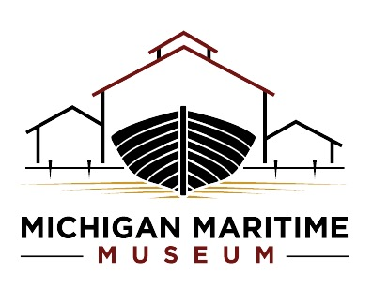
The Michigan Maritime Museum
MichiganMaritimeMuseum.org
Contact: brent@mimaritime.org or 269-637-8078, ext. 202
FOR IMMEDIATE RELEASE
Free Fun Fest Returns June 6 at Michigan Maritime Museum
A free, waterfront celebration powered by community partnerships across South Haven
South Haven, MI — The Michigan Maritime Museum invites families from across the region to experience the 2nd annual Free Fun Fest on Saturday, June 6, from 11 a.m. to 3 p.m.—a high-energy, waterfront celebration filled with hands-on activities, live demonstrations, and family fun. This event is completely free and open to all.
Park off site and hop on the free shuttle to enjoy everything this special day has to offer. To make the event accessible for everyone, a free city-wide shuttle will run throughout the day with stops at the South Haven Senior Center, South Haven City Hall, and the Museum. The Shuttle will run from 8:00 am to 4:00 pm to include the Krusin’ with Kylie Car Show.
Now one of the community’s most anticipated summer kickoffs, Free Fun Fest is made possible through the collaboration of more than four dozen local businesses and organizations, including the City of South Haven, Visit South Haven, Destination Paw Paw, the South Haven Fire Department, the South Haven Police Department, South Haven Public Schools, and the Michigan Maritime Museum, all coming together to create an unforgettable day on the harbor.
The Museum campus at 260 Dyckman Avenue will come alive with interactive experiences for all ages. Guests can explore emergency vehicles up close, test their skills on a ninja obstacle course, enjoy robotics demonstrations, and participate in hands-on learning stations celebrating Great Lakes history and science. Inside the Museum, exhibits will be open for exploration, while outside, the waterfront becomes a vibrant hub of activity.
New and returning highlights include:
● Limited free boat rides offering a rare chance to get out on the water
● Dockside tours of the historic tall ship Friends Good Will, the Museum’s flagship vessel ● More than a dozen carnival-style game booths including Shootin’ Hoops, Sailor Knots, Games of Chance, Disc Golf, and more
● A Fairy Forest Walk, Giant Dino Dig, lawn bowling, and arcade-style games
● A library book giveaway and interactive learning challenges
● Complimentary ice cream and root beer for guests
Food and raffle tickets will be available for purchase for just $1 each (cash only), offering affordable options for families while supporting the Museum’s programming.
Free Fun Fest reflects the Michigan Maritime Museum’s commitment to accessible, engaging education and meaningful community connection, bringing together partners, families, and visitors to celebrate the spirit of South Haven and its rich maritime heritage.

For more information, visit MichiganMaritimeMuseum.org or follow along on social media for event updates.
###

