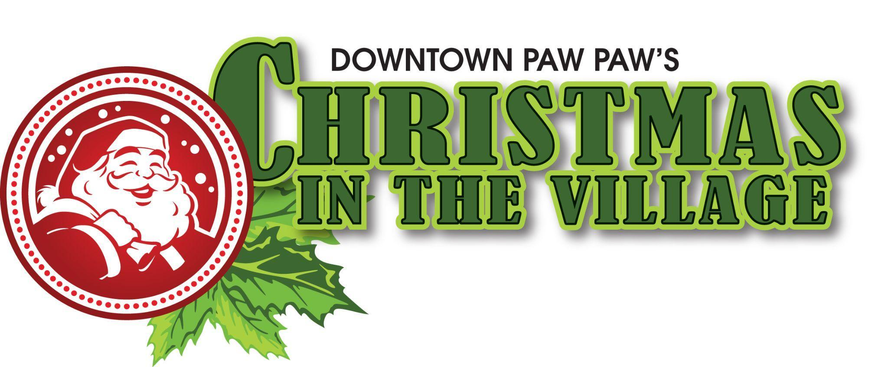

FOR IMMEDIATE RELEASE
November 18, 2025
Paw Paw, Michigan

Paw Paw Launches New “Christmas in the Village” Celebration
December 12th & 13th, 2025
Paw Paw will sparkle with holiday cheer this season as the community debuts its new Christmas in the Village celebration — two days of festivities, local spirit, and small-town magic.
The event kicks off Friday, December 12th, with the Lighted Holiday Parade at 6:00 p.m. through downtown, led by this year’s Grand Marshals, Roman and Ava Plaszczak. Community members, organizations, and businesses are invited to take part — and there’s still time to sign up for the parade here. The Tree Lighting Ceremony at the Courthouse follows at 6:45 p.m., where Paul DeYoung will be honored with the Community Ambassador Award. Photos with Santa will follow the tree lighting.
Festivities continue Saturday, December 13, with the Rotary 5K Santa Run at 9:00 a.m. (register here), followed by Kringle Town on Paw Paw Street from 10:00 am to 4:00 pm., featuring old-world charm and handcrafted gifts in wooden market houses donated by Meyer Wood Products. The day also includes the Merry Village Mingle throughout downtown shops.
Families can also enjoy Pictures with Santa at the Carnegie on Saturday from 10:00 am to 4:00 pm, where children can visit Santa, share their wish lists, and enjoy cookies and cocoa. This is a no-cost family event open to all.
Enjoy wassailing by the Paw Paw Village Players, live ice sculpting sponsored by Destination Paw Paw, and support from the DDA, Chamber of Commerce, Van Buren County Commissioners, the Village of Paw Paw, and many volunteers.
“Christmas in the Village is about bringing our community together to celebrate the magic of the season,” said Janice Chittle from Destination Paw Paw. “We’re so proud of how many local businesses, volunteers, and organizations came together to make this new holiday tradition possible.”
“Christmas in the Village is truly a reflection of what makes Paw Paw so special,” added Mary Springer, DDA Coordinator. “This event came together through the hard work of so many — our local businesses, volunteers, and community partners, all joining forces to bring something joyful and new to downtown. It’s a wonderful example of what can happen when we work together.”
Celebrate the season — Christmas in the Village brings holiday magic to downtown Paw Paw! For more information, visit our Christmas in the Village Facebook Page.

Media Contacts


Janice Chittle
Destination Paw Paw
info@destinationpawpaw.org

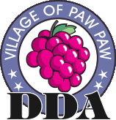
Mary Springer
Paw Paw Downtown Development Authority
m.springer@pawpaw.net

